Lap 4 Postgres

1-
create function multiplenums(x int, y int)
returns int as $$
declare
res int;
begin
res = x*y;
return res;
end;
$$LANGUAGE plpgsql;
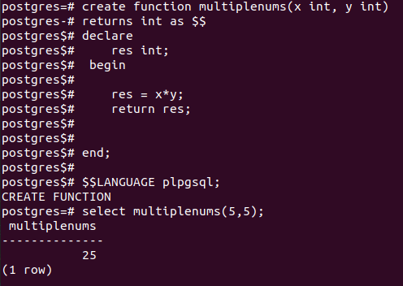

2-
create function returntype(x int)
returns void as $$
begin
if (x %2)=0 then
raise notice 'this is even no.';
else
raise notice 'this is odd no.';
end if;
end;
$$LANGUAGE plpgsql;
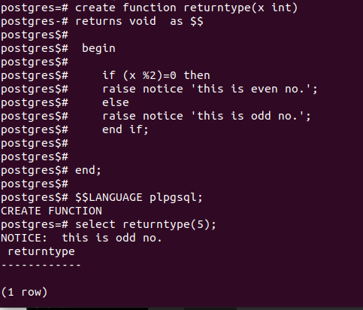

3-
create or replace function AddNewStudent (student_id int,fname text, lname text , bdate date , tid int , tname text )
returns void as $$
begin
insert into track (track_id ,name) values ($5 , $6 );
insert into students (student_id,track_id,fname , lname , bdate ) values ($1,$5,$2,$3,$4);
end;
$$LANGUAGE plpgsql;
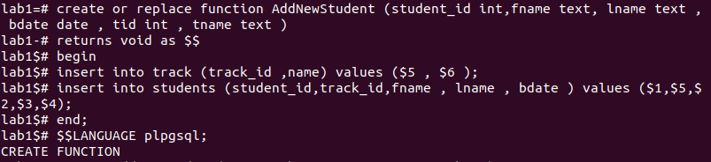
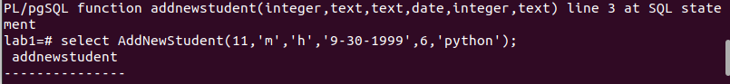
4-
create or replace function St_Score (stu_id int , sub_id int)
returns int as $$
declare select_score int;
begin

select student_score into select_score from exam where subject_id=$2 and student_id=$1;

return select_score;
end;
$$LANGUAGE plpgsql;

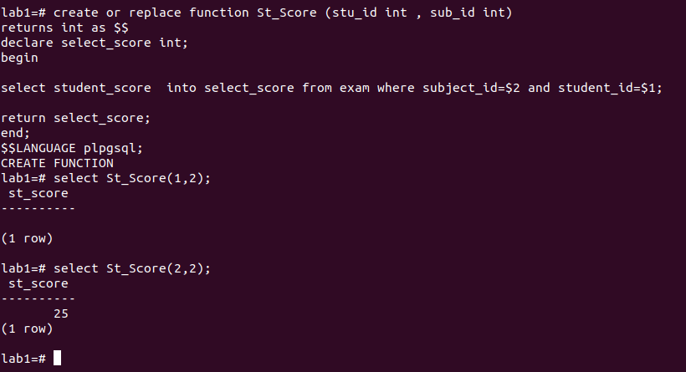

5-
create or replace function stu_failed ( sub_id int)
returns int as $$
declare stu_no int;
begin

select count(student_id) into stu_no from exam where subject_id=($1) and student_score<50;

return stu_no;
end;
$$LANGUAGE plpgsql;

6-
create or replace function avg_subject ( sub_name text)
returns int as $$
declare avg_sub int;
begin

select avg(max_score) into avg_sub from subjects where name=($1);

return avg_sub;
end;
$$LANGUAGE plpgsql;

7-
create table persons (id serial primary key , name text , gender gender);

8-
create table staff_members ( dept_name text , course_name text) INHERITS (persons);
